EX3 – FILE TRANSFER USING TCP
- S. Vishakan CSE – C 18 5001 196

Server Program:

#include <stdio.h>
#include <unistd.h>
#include <sys/types.h>
#include <sys/socket.h>
#include <netinet/in.h>
#include <string.h>
#include <fcntl.h>

int main(int argc, char **argv){
int sockfd, flag, newfd, i = 0, len;
struct sockaddr_in server, client;
FILE *fp;
char file_name[100];
char buffer[1024];

sockfd = socket(AF_INET, SOCK_STREAM, 0);

if(sockfd < 0){
perror("\nSocket cannot be created.");
exit(0);
}

bzero(&server, sizeof(server));

server.sin_family = AF_INET;
server.sin_addr.s_addr = INADDR_ANY;
server.sin_port = htons(7228);

if(bind(sockfd, (struct sockaddr*)&server, sizeof(server)) < 0){
perror("\nBind error occurred.");
exit(0);
}

printf("Waiting for client...\n");

listen(sockfd, 2);

len = sizeof(client);
newfd = accept(sockfd, (struct sockaddr*)&client, &len);
flag = read(newfd, file_name, sizeof(file_name));

printf("File to be read: %s", file_name);

fp = open(file_name, O_RDONLY); //Open the specified file in read-only mode

if(fp < 0){ //If file does not exist.
perror("\nSpecified file could not be found.\n");
strcpy("Error 404", buffer);
return 1;
}

else{
len = read(fp, buffer, 1024); //len stores the no. of characters read by read()
close(fp);

flag = write(newfd, buffer, len);
printf("\nFile contents transferred.\n");
}
close(newfd);
close(sockfd);

return 0;
}

Output:

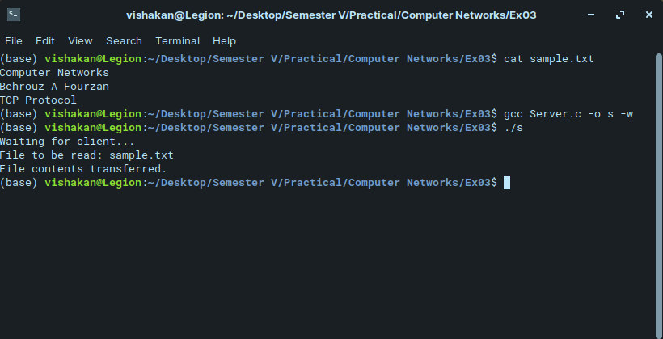
Client Program:

#include <stdio.h>
#include <unistd.h>
#include <sys/types.h>
#include <sys/socket.h>
#include <netinet/in.h>
#include <string.h>
#include <fcntl.h>

int main(int argc, char **argv){
int sockfd, flag, i = 0, len;
struct sockaddr_in server, client;
FILE *fp;
char file_name[100];
char buffer[1024];

sockfd = socket(AF_INET, SOCK_STREAM, 0);

if(sockfd < 0){
perror("\nSocket cannot be created.");
exit(0);
}

bzero(&server, sizeof(server));

server.sin_family = AF_INET;
server.sin_addr.s_addr = inet_addr(argv[1]);
server.sin_port = htons(7228);

printf("\nEnter the File Location: ");
scanf(" %[^\n]", file_name);

connect(sockfd, (struct sockaddr*)&server, sizeof(server));

flag = write(sockfd, file_name, sizeof(file_name));
flag = read(sockfd, buffer, sizeof(buffer));

if(strcmp(buffer, "Error 404") == 0){ //if file was not found
printf("File %s was not found.\n", file_name);
close(sockfd);
exit(0);
}

printf("File contents transferred.");

fp = open("newfile.txt", O_WRONLY|O_CREAT, S_IRWXU);
//create a newfile to store the content in client machine with proper permissions

len = strlen(buffer);
write(fp, buffer, len);
close(fp);

printf("\nContents of %s written to \"newfile.txt.\"\n", file_name);
close(sockfd);

return 0;
}

Output:

